Breath Prayer: Holy Spirit, help us pray.
Please quiet voices, hearts and cell phones in preparation for worship.
†Welcome – Psalm 119:129-136
Call To Worship
*Hymn #384 “The Bond of Love”
Matthew 13:31-33, 44-52
*Hymn #599 “We Praise You with Our Minds, O Lord”
Offertory
*Doxology #253
Special Music “Hallelujah”
Sermon “Helping Holy Spirit” Romans 8:26-39
*Hymn #486 “Lord, Here Am I”
†Benediction
†Postlude “O For the Wings of a Dove” / “Largo”

*If you are able, please stand.
†Please remain seated.
If you are interested in joining Kilmarnock Baptist Church or making a public profession of faith, you may come forward during the final hymn.

Today’s flowers are given in loving memory of Thomas Cecil Bromley by Anne Bromley, his wife, and by his daughter, Beth Cornwell.

TODAY!
- Quarterly business meeting after service followed by a potluck lunch. Volunteers needed to set up and tear down.
- Come and fellowship with our Hispanic friends and their leaders in this vital ministry at 4pm in the fellowship hall. Everyone understands a smile! Pastors Kenny Park and Brooke Carrillo will bring groups from their Spanish-speaking congregations. After fellowship and conversation, dinner will be served around 5pm, followed by worship in Beane Hall. All are invited! (Contact: Louise Humphreys at 435-1412 or louhum@yahoo.com)

You’re invited to join us next Sunday immediately following the 11am service for a coffee hour in honor of Courtney Reisner’s 40th birthday, and in memory of her dear friend, “Kit” Monroe.

Mid-year giving statements are available for pick up behind sanctuary in hallway.

Choir practices begin again on August 6.

To support CBF missionaries Andy and Jutta Cowie in their work in Haiti, go to http://www.thefellowship.info/give-now/, click on light blue tab “Mission Communities/Projects”, select last option “Specific project (type in box below)”, enter “project number 87104”, and fill in amount and your billing info.

The 2nd Annual Talent/Non-Talent Show will be August 16 at 2pm and will be hosted by our JOY Ministry. To sign-up, contact Bob Gray or any member of JOY.

All are invited to the “Master’s Blend” Class Picnic at Belle Isle State Park on August 23. Gather at 4pm at the “Humphrey’s Shelter” and enjoy food and drinks around 5:30. Bring a side dish to share. Special music by Tommy Thompson. Parking is $4/car.

To ensure that your notes get to Doris Christopher, please mail them to her home address and her family will deliver them. (51 Pohickory Lane, Irvington, 22480)

To those who give flowers in honor or memory of loved ones on Sundays, please remember to take your arrangements with you upon departure so the flowers can be enjoyed throughout the week. Thank you.
Lift Up In Prayer…
Marge Arnold (former member), Family of Linda Ender-Bailey (daughters Elisa Enders and Elizabeth McGill, and sister Brenda Watson), Toi Beane, Doris Christopher, Phyllis Cook (Lancashire), Ida Gallimore, Steve Gallimore, Robert Gibson, Kori Godwin, E.W. Haynie, Ken Holloway, Betty Holmes, Mel Holmes, Betty Jones, Ann Perry and Family, Helen Quillan, Ralph Ransone, Warren and Augusta Sellew, Lisa Spiers, Joan Thomas, Sam & Gladys Watson, Mary Webb, Carolyn Wilkins and her parents.

This Week at KBC…
Today: 10am Worship; Business Meeting after Worship;
Potluck Lunch after Business Meeting
Tuesday: 4pm Alanon
Thursday: 8pm Alanon

Serving in Worship Today…
Organist: Phillip Humphreys
Soloist: Denise Goodson
Guitarist: David Humphreys
Deacon of the Week: Agnes Holloway (438-5391)
Nursery worker: Carlie Gill
Radio Room: Gerald Abbott, Oliver Crane, Don Headley and Troy Pouchot

Budget giving 7/20/14 $2,562.00
Budget requirement $3,988.00
Difference (-) $1,426.00

Church Info...
Office Hours: M/T/W/F 8am-1pm; Thursday 9am-1pm
PO Box 99, Kilmarnock, VA 22482
(804) 435-1703
www.kilmarnockbaptist.org
info@kilmarnockbaptist.org; twitter@kilmarnockbc
Kilmarnock Baptist Church

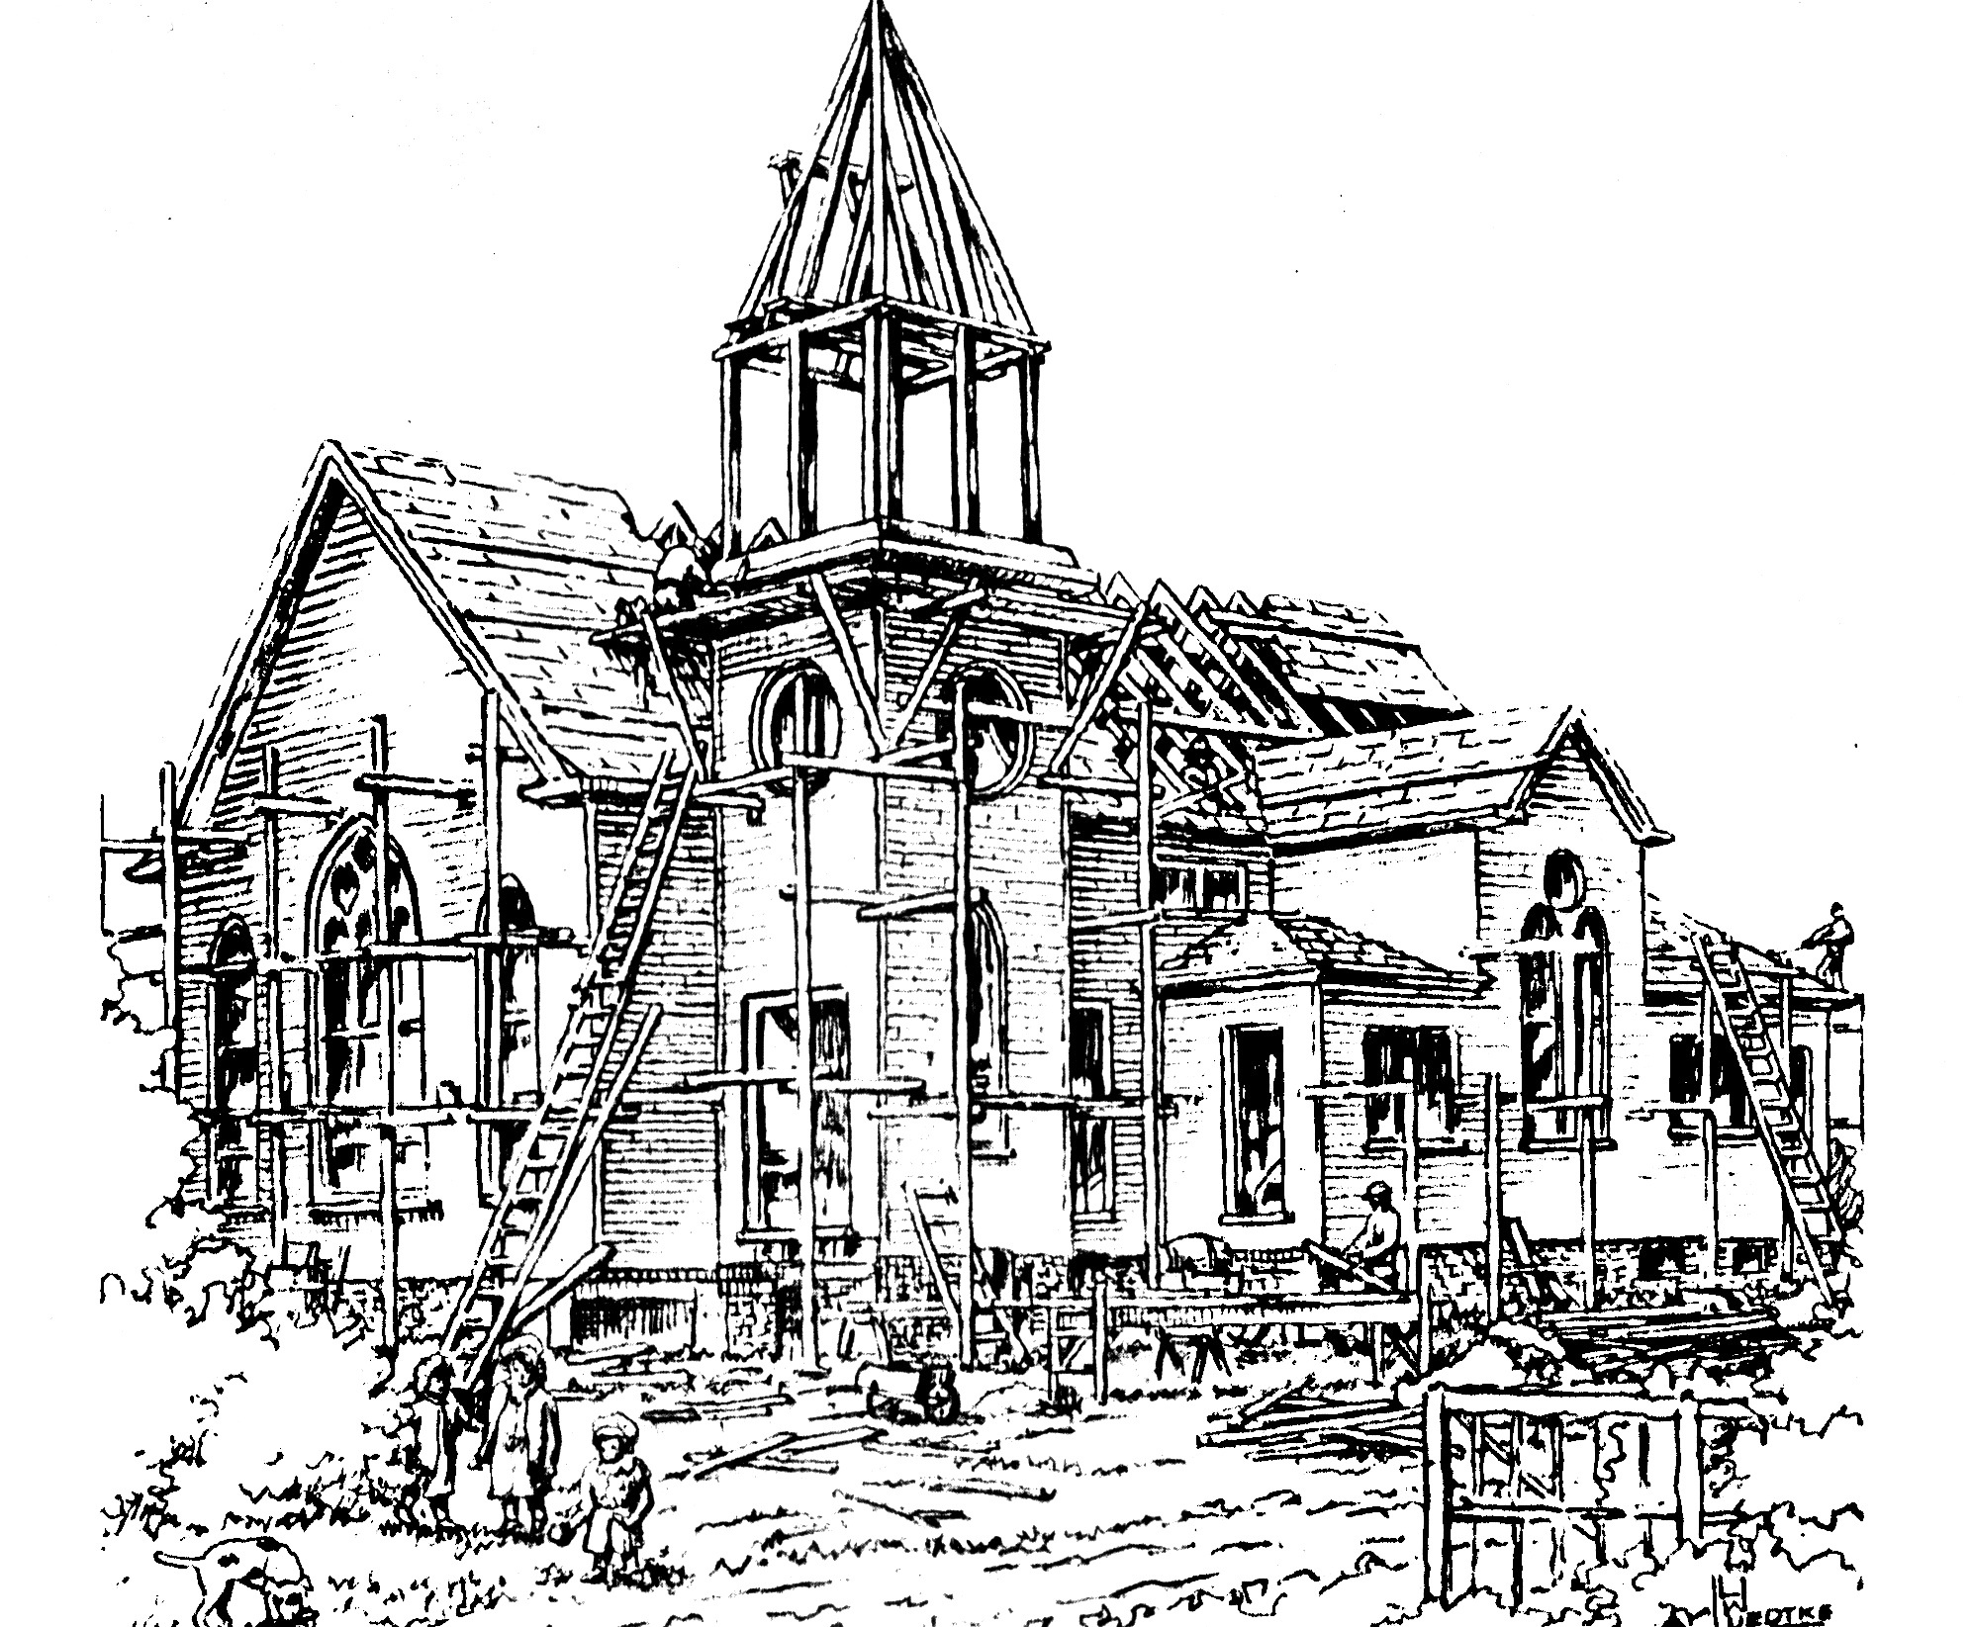

7th Sunday After Pentecost
July 27, 2014
Matthew Tennant, Pastor
Carolyn Williams, Associate Pastor
Robbie Spiers, Music Director
Audrey Davis, Ministry Assistant
Mary Ann Crane, Organist
Laura E. Bridges, Pianist

