Breath Prayer: Lord, give me quiet and peace in you.
Please quiet voices, hearts and cell phones in preparation for worship.
†Welcome – Psalm 139:1-12, 23-24
Prelude “Reflections from a Stained Glass Window”
Call To Worship “We Adore You, Lord Jesus Christ”
*Hymn #54 “Great Is Thy Faithfulness”
Matthew 13:24-30, 36-43
Mission Moment
*Hymn #64 “God Will Take Care of You”
Offertory “A Quiet Blessing”
*Doxology #253
Special Music Duet “Here I Am, Lord”
Sermon “It’s Going to Be Okay” Romans 8:12-25
*Hymn #73 “God Moves in a Mysterious Way”
†Benediction
†Postlude “Christ, Our Strength and Consolation”
*If you are able, please stand.
†Please remain seated.
If you are interested in joining Kilmarnock Baptist Church or making a public profession of faith, you may come forward during the final hymn.

Today’s flowers are given by Danny Tobin in loving memory of his wife, Nancy, remembering her July 21st birthday.

Join us TODAY at a coffee hour after the 11am service to say “Farewell!” and “Thank You!” to Laura Bridges for her time serving as our pianist.

Did you notice the info on today’s bulletin cover? If not, check it out!

The annual Hispanic gathering hosted by our WMU will be at 4pm Sunday, July 27. Pastors Kenny Park and Brooke Carrillo will bring groups from their Spanish-speaking congregations. Dinner will be served around 5pm followed by a worship service in Beane Hall. All are welcome! If you have questions or would like to help, contact Louise Humphreys at 435-1412 or louhum@yahoo.com.

Next Sunday - Amazing Grace program “Fracking: Implications for the Northern Neck” from 3-5pm at Trinity Episcopal Church, Lancaster. The presenter will be Albert Pollard, concerned citizen and former Member, VA House of Delegates. Music will be presented by Nouvelet. Call St. Andrews for details. (435-3948)

To support CBF missionaries Andy and Jutta Cowie in their work in Haiti, go to http://www.thefellowship.info/give-now/, click on the light blue tab “Mission Communities/Projects”, select the last option “Specific project (type in box below)”, enter “project number 87104”, and fill in the amount you wish to give and your billing info. If you need any help, please let the church staff know.

The 2nd Annual Talent/Non-Talent Show will be August 16 at 2pm and will be hosted by our JOY Ministry. To sign-up, contact Bob Gray or any member of JOY.

All are invited to the “Master’s Blend” Class Picnic at Belle Isle State Park on Saturday, August 23. We‘ll gather at 4pm at the “Humphrey’s Shelter”.
Food and drinks will be provided around 5:30. Bring a side dish to share. Tommy Thompson will bring us special music. Parking is $4 per car.

To ensure that your cards/notes get to Doris Christopher, please mail them to her home address and her family will take them to her during visits. (51 Pohickory Lane, Irvington, 22480)

Lift Up In Prayer…
Marge Arnold (former member), Linda Ender-Bailey’s family (daughters Elisa Enders and Elizabeth McGill, and sister Brenda Watson), Toi Beane, Doris Christopher, Phyllis Cook (Lancashire), Ida Gallimore, Steve Gallimore, Robert Gibson, Kori Godwin, E.W. Haynie, Ken Holloway, Betty Holmes, Mel Holmes, Betty Jones, Ann Perry and Family, Helen Quillan, Ralph Ransone, Warren and Augusta Sellew, Lisa Spiers, Joan Thomas, Sam & Gladys Watson, Mary Webb, Carolyn Wilkins and her parents.
- Combined Service @ 10am

- Business Meeting after Service

- Potluck after Meeting
  - Please bring a dish to share
  - Volunteers needed to set up and clean up
This Week at KBC…
Today: 9am Worship; 9:45am Sunday School; 11am Worship;
Coffee Hour after 11am service
Tuesday: 4pm Alanon
Thursday: 8pm Alanon and Alateen

Serving in Worship Today…
Special Music Duet: Lynnie and Winnie McCrobie
Deacon of the Week: Gary Wilkins (435-2138)
Nursery worker: Carlie Gill
Radio Room: Gerald Abbott, Oliver Crane, Don Headley and Troy Pouchot

Budget giving 7/13/14 $3,695.00
Budget requirement $3,988.00
Difference (-) $293.00

Church Info...
Office Hours: M/T/W/F 8am-1pm; Thursday 9am-1pm
PO Box 99, Kilmarnock, VA 22482
(804) 435-1703
www.kilmarnockbaptist.org
info@kilmarnockbaptist.org; twitter@kilmarnockbc

Kilmarnock Baptist Church
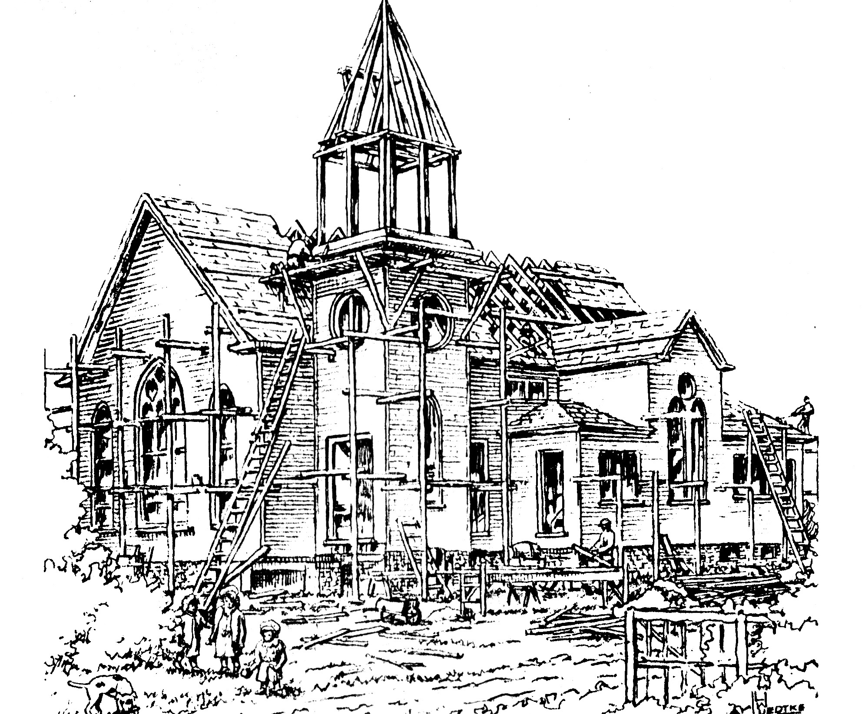

Next Sunday

6th Sunday After Pentecost
July 20, 2014
Matthew Tennant, Pastor
Carolyn Williams, Associate Pastor
Robbie Spiers, Music Director
Audrey Davis, Ministry Assistant
Mary Ann Crane, Organist
Laura E. Bridges, Pianist

